**PROJECT REPORT ON**

**IMAGE EDITOR**

SUBMITTED BY

**Mr. AMIT ASHOK MANORE (1133442)**

**Mr. CHETAN ARVIND KAMBLE (1133382)**

UNDER THE GUIDANCE OF

**Prof. NARENDRA INGALE**

SUBMITTED IN PARTIAL FULFILLMENT OF THE REQUIREMENTS FOR QUALIFYING B.Sc. (I.T), SEMESTER-VI EXAMINATION

**VIKAS COLLEGE OF ARTS SCIENCE & COMMERCE,**

(AFFITIATED TO UNIVERSITY OF MUMBAI),

KANNAMWAR NAGAR NO.2,

VIKHROLI (EAST), MUMBAI- 400083.

**YEAR 2014-2015**

**CERTIFICATE**

This is to certify that Project entitled **Image Editor Application**

undertaken at the **Vikas college of Arts Science & Commerce** by **Mr. Amit Ashok Manore** Seat no.**1133442** in partial fulfillment of B.Sc. IT degree (Semester VI) Examination had not been submitted for any other examination and does not form part of any other course undergone by the candidate.

It is further certified that he has completed all required phases of the project.

Head of the Internal Examiner

Department Project Guide

External Examiner

**CONTENTS**

1. **PREFACE…………………………………………………………. 6**

**ACKNOWLEDGEMENT………………………………………... 7**

1. **SYNOPSIS……………………………………………………….... 8**

3.1 INTRODUCTION TO PROJECT…………………………….. 9

3.2 PROBLEM DEFINATION…………………………………… 10

3.3 OBJECTIVES OF PROPOSED SYSTEM……………………. 11

3.4 ROLE AND SCOPE OF PROJECT…………………………… 12

3.5 ADVANTAGES OF THE PROPOSED SYSTEM…………….. 13

**4**. **SYSTEM ANALYSIS**

4.1 REQUIREMENT GATHERING…………………………………. 15

4.2 REQUIREMENT ANALYSIS……………………………………. 15

**5. REQUIREMENT SPECIFICATION**

5.1 INTRODUCTION……………………………………………… 17

5.1.1 PURPOSE………………………………………………….17

5.1.2 SYSTEM OVERVIEW……………………………………. 17

5. 2 OVERALL DESCRIPTION………………………………….. 18

5. 2.1 SOFTWARE REQUIREMENT………………………….18

5.2.2 HARDWARE REQUIREMENTS………………………..18

5.3 SPECIFIC REQUIREMENT…………………………………. 19

5.3.1 FUNCTIONAL REQUIREMENT…………………………..19

5.3.2 PERFORMANCE REQUIREMENTS……………………..21

5.3.3 DESIGN CONSTRUCTIONS……………………………….21

5.3.4 PROJECT CONSTRUCTIONS……………………………..21

**6. FEASIBILITY STUDY**

6.1 FEASIBILITY**…………………………………………………….. 23**

6.1.1 TECHNICAL FEASIBILITY……………………………………..24

6.1.2 OPERATIONAL FEASIBILITY…………………………………24.

6.1. 3 ECONOMICAL FEASIBILITY…………………………………..25

6.1.4 SCHEDULE FEASIBILITY……………………………………….26

**6.2** **QUESTIONS REGARDING FEASIBILITY……………………………………. 26**

**6.3 QUESTIONS ON FEASIBILITY OF OUR PROJECT…………………………. 29**

6.4 TECHNOLOGY USED…………………………………………………31

**7**.  **METHODOLOGY INVOLVED**

7.1 MODEL USED………………………………………………………. 33

7.2 JUSTIFICATION……………………………………………………. 35

**8. PROJECT SCHEDULE**

8.1 GANTT CHART…………………………………………………… 37

**9. SYSTEM DESIGN……………………………………………………….**

9.1 USECASE DIAGRAM………………………………………………. 40

9.2 ACTIVITY DIAGRAM………………………………………………. 43

9.3 SEQUENCE DIAGRAM……………………………………………… 46

**10. TESTING…………………………………………………………………..**

10.1 TESTING…………………………………………………………… 51

10.2 Testing objectives…………………………………………………… 52

10.3 STRATEGIES USED FOR SOFTWARE TESTING………………... 53

**11. SCREEN SHOTS………………………………………………………. 54**

**12. DEPLOYMENT………………………………………………………….. 66**

12.1 DEPLOYMENT……………………………………………………… 67

12.2 SOFTWARE DEPLOYMENT ………………………………………67

**13. SYSTEM MAINTENANCE AND EVOLUTION**

* 1. SYSTEM MAINTENANCE…………………………………………69
  2. CORRECTIVE MAINTENANCE………………………………….69

13.3ADAPTIVE MAINTENANCE……………………………………….69

13.4 PERFECTIVE MAINTENANCE……………………………………70

13.5PREVENTIVE MAINTENANCE………………………………….70

13.6 FUTURE ENHANCEMENT………………………………………70

**14. CONCLUSION……………………………………………………………71**

**15. BIBLIOGRAPHY………………………………………………………… 74**

**PREFACE**

The main objective of this project is to view the image and make image very attractive. In this project you can made the adjustment of the image by zooming, cropping and rotating. You can change the brightness of the image.

You can apply the noise effect and in between the noise effect you can apply the various filter effect. If you have applied the effect then you can also adjust the effect in another frame. You can zoom, crop and rotate the images after applying effect you can check the status of RGB color by using the RGB histogram.

Another option is the grayscale effect that you can make the image as the black and white as draw able image. You can apply the effect base on the threshold value.

And after doing all operation you can save the image in between the effect. For example if you have applied the effect noise then new frame will open and then you can save the image after applying effect and also you can apply the filter option after noise. You can also save the image after adjustment.

**ACKNOWLEDGEMENT**

We wish to express our profound thanks to all those who helped in making this book much needed moral support and encouragement is provided on numerous occasions by our whole team.

We are especially grateful to the great teacher Prof.Narendra Ingale for his time to time, much needed, valuable guidance. Without the full support and cheerful encouragement of Prof. Vikas Raut Sir (H.O.D of IT) the book would not have been completed in time.

Finally, we wish to thank entire team of technical staff of IT department who have taken immense pain to make for project book in time. Thanks to all

**SYNOPSIS**

**3.1 INTRODUCTION TO PROJECT**

During the past decade, increasing attention has been focused on the technology of computer software. As manual computing system become more numerous, complexes the need for systematic approaches to software development become increasingly apparent.

The objectives of project image Editing for a user is to develop good software to overcome the existing system. In existing system we can only view the image and create the zoom in, zoom out we can’t modify and manage the image as wants.

The project is written for the user where the user can easily get through image and user who wants viewing and editing the enhancement of the image will get more advantages from this software.

In a simple captured image is taken from mobile. The image is displayed as the user wants sometimes image are not viewable we need to image the brightness and color enhancement and managing the various editing activity.

**3.2 PROBLEM DEFINATION**

The objectives of project image Editing for a user is to develop good software to overcome the existing system. In existing system we can only view the image and create the zoom in, zoom out we can’t modify and manage the image as wants.

The project is written for the user where the user can easily get through image and user who wants viewing and editing the enhancement of the image will get more advantages from this software.

**3.3 OBJECTIVES OF PROPOSED SYSTEM**

The system which will developed now make more interactive to the user much easier. By this system the user can view the image and edit the image as he/she wants. The user can change the brightness and many other facility that the user will easily and clearly view the image. User can out the image part from the image and make changes in remaining part .Also draw from the pencil in newly created region in the project.

The system will enables not only to view but also to edit. You can open the picture and making editing. There is also option for saving the image changes and saving as a separate image file. You can also restorethe image setting as it’s have before editing have. You can also know the status of the color by histogram of RGB model.

**3.4 ROLE AND SCOPE OF PROJECT**

The main objective of using this project is to display the image and also to make the editing in the image.

User can do the following operation on image i.e. crop the image, Insert Text, Rotate image, make image in black & white format , make mirror image, provide blur effect, change the size of image, oil painting effect, etc.

3.5 ADVANTAGES OF THE PROPOSED SYSTEM

Any photo editing software offers the following features

* Data compression
* Image Selection properties
* Use of layers in image editing
* Resizing image
* Cropping of images
* Color change of image parts
* Image rotation
* Black and white image
* Blur the image

**SYSTEM ANALYSIS**

**REQUIREMENT GATHERING**

Based on the scope and nature of the particular software project, requirement analysis is carried out by an independent business analyst or a team of analysts to capture requirements. Typically requirements analysis involves capturing both functional and non-functional requirements and requires both technical and business expertise.

To ensure effective capturing of requirement we follow a holistic process involving these broad steps:

**REQUIREMENT ANALYSIS**

Once user data is gathered, structured analysis is carried out on this data to arrive at models. Usually use-cases are developed to analyze the data on various parameters depending on the larger goals of the software solution. A few techniques used include requirements animation, automated reasoning, knowledge-based critique, consistency checking, analogical and case-based reasoning.

**REQUIREMENT SPECIFICATION**

**5.1 INTRODUCTION**

**5.1.1 PURPOSE**:

During the past decade , increasing attention has been focused on the technology of computer software. As manual computing system become more numerous , complex the need for systematic approaches to software development become increasingly apparent.

The objectives of project image viewer for a user is to develop good software to overcome the existing system. In existing system we can only view the image and create the zoom in , zoom out we can’t modify and manage the image as wants.

The project is written for the user where the user where the user can easily get through image and user who wants viewing and editing the enhancement of the image will get more advantages from this software .

In a simple captured image is taken from mobile. The image is displayed as the user wants sometimes image are not viewable we need to image the brightness and color enhancement and managing the various editing activity.

.

**5.1.2 SYSTEM OVERVIEW**

The system is desktop application The system which will developed now make more interactive to the user much easier. By this system the user can view the image and edit the image as he/she wants. The user can change the brightness and many other facility that the user will easily and clearly view the image. User can out the image part from the image and make changes in remaining part.

The system will enables not only to view but also to edit. You can open the picture and making editing. There is also option for saving the image changes and saving as a separate image file. You can also restore the image setting as it’s have before editing have

**5.2 OVERALL DESCRIPTION**

**5.2.1 SOFTWARE REQUIREMENT**

* **OPERATING SYSTEM:-**Windows XP, Window 7, Window 8, Windows VISTA
* **Front end**: DOT NET FRAMEWORK

**5.2.2 HARDWARE REQUIREMENTS**

* **RAM**: 512 MB
* **HARD DISK**: 100 MB
* **PROCESSOR**: DUAL CORE 1.65 GHMONITOR: 19’

**5.3 SPECIFIC REQUIREMENT**

**5.3.1 FUNCTIONAL REQUIREMENT**

**1: CROPPING**

* First open the image on which we want to perform cropping operation
* Select the part of the image which we want to crop
* After that clicks on the ‘’OK’’ button. The image will be crop.
* After that he can save that editing image .

**2: BLUR**

* User will open the image on which he want to provide blurring effect .
* After that click on ‘’OK’’ button.
* The blur effect will be show on image.
* After this he can save the image wherever he want to save.

**3: INSERT TEXT**

* This feature of image allow the user to write the text on the image at any part of image
* For doing this he will first this image
* Then he will first select the part of the image where he wants to write text.
* After that he will write the text and also can provide the various style to it.

After clicking on ’’OK’’ button the text will be seen on the image.

**4: ROTATE IMAGE**

* This features will allow the user to rotate the image by 90 , 180 .
* For this user will first open the image on which he wants to perform this operation.
* And after that by clicking on ”ROTATE RIGHT’ button the image will be rotate by 90 &by clicking on ‘’ROTATE LEFT’’ button the image will be rotate anticlockwise by 90,
* After the he can save the edited image whenever he want to save.

**5: RESIZE THE IMAGE**

* This feature will allow the user to zoom out or zoom in the image size.
* For that he can also specify the exact size of the image
* For this user will use the track bar to set resolution. By which he can increase or decrease the size of the image.
* After that he can save that edited image.

**6: BLACK & WHITE EFFECT ON IMAGE**

* This feature allows the user to provide black & white effect to the image.
* For that first of all he will select the image on which he wants to provide this effect.
* After that click on ‘’ BLACK & WHITE OK ‘’ button.
* After that he can save the image on PC where he want.

**7: FLIP (MIRROR IMAGE)**

* This feature allows the user to make the mirror image of the original image.
* For that he has to 1st open the image from the “FILE NAME “ or can directly use the short cut “Ctrt +o” to open the image.
* After opening the required image click on the “OK” button from the right hand side the mirror image will be produced.

**5.3.2 PERFORMENCE REQUIREMENTS**

* S/w should process all format of the image in different format click from.PNG to .jpeg.
* S/w should be allow the user to do this.

**5.3.3 DESIGN CONSTRUCTIONS**

* The designed should be developed such that it is easy for the user to use.

**5.3.4 PROJECT CONSTRUCTIONS**

1: POTABILITY

* We can install this software in any window Operating System.

2: AVAILABILITY

* Once the s/w installed on the PC it can be used by any user.

FEASIBILITY STUDY

**6.FEASIBILITY STUDY :**

Feasibility study is essential to evaluate cost and benefit of the proposed system. This is very important step because on the basis of this; system decision is taken on whether to proceed or to postpone the project or to cancel the project.

**NEED OF FEASIBILITY STUDY :**

* It determines the potential of existing system.
* It finds or defines all problems of existing system.
* It determines all goals of the system.
* It finds all possible solutions of the problems of existing system. We can call it as proposed system.
* It finds technology required to solve these problems.
* It determines really which solution is easy for operational from the point of view of customer and employees such that it requires very less time with 100% accuracy.
* It determines what hardware and software is required to obtain solution of each problem or proposed system.
* It determines cost requirements of the complete proposed system in terms of cost of hardware required, software required, designing new system, implementation and training, proposed maintenance cost.
* It avoids costly repairs, crash implementation of new system.
* It chooses such system which is easy for customer to understand and use so that no special training is required to train the customer. It may give some training to employees of the system.

Four Types of feasibility studiesare :-

1. Technical
2. Economical
3. Operational
4. schedule

All are equally important.

**6.1.1 TECHNICAL FEASIBILITY :**

* The committee first finds out *technical feasibility of the existing system.* It involves following steps :
* It determines available hardware.
* It determines available computer with configuration.
* It determines available software.
* It determines operating time of available system that is computer, hardware software.

**6.1.2**. **OPERATIONAL FEASIBILITY:**

It is also called as behavioral feasibility. It finds out whether the new technology or proposed system will be suitable using three type of aspects; that are human, organizational and political aspects. It involves following steps :

* It finds out whether there is any direct-indirect resistance from the user of this system or not?
* It finds whether the operation of proposed system is easy or not as compare to existing system.
* It finds out whether the user or customer of the system requires extra training or not?
* If it requires any retraining then it is accepted by user as well as customer or not?
* It finds if any job reconstruction is required or not ?
* It finds if this reconstruction of the job is accepted in organization ?
* It also finds if it is acceptable then what should be the skill sets of that job.
* Watches the feelings of the customers as well as users.

**6.1.3** **ECONOMICAL FEASIBILITY:**

Here, steering committee finds total cost and all benefits as well as expected savings of the proposed system.

There are two types of costs - ***onetime cost* and *recurring costs****.* **One time cost** involves following:

* Feasibility study cost.
* Cost converting existing system to proposed system.
* Cost to remolding architecture of the office, machineries, rooms etc.
* Cost of hardware’s.
* Cost of Operating system software.
* Cost of Application software.
* Technical experts consulting costs.
* Cost of training.
* Cost of Documentation preparation

**6.1.4** **SCHEDULE FEASIBILITY**

Schedule feasibility is defined as the likelihood of a project being completed within its schedule time frame. If the project has a high likelihood of completion by the desire due date, then schedule feasibility is considered to be high.

A schedule should be set up with a grant chart, with the completion time for each step determining the start date for the subsequent dependent task. An optional schedule uses the least amount of time. A schedule is not feasible if all necessary steps, when completed in order, take more time together done in sequence than the project time allows.

Schedule feasibility can be calculated using operations research method. In project we are taken less time for design and taken the more time for implementation. A probability of the time period for which a step is completed is assigned. A software program can use to determine the odds of a project being completed within the desired completion date

**6.2 QUESTIONS REGARDING FEASIBILITY**

1. **What is the purpose of the project? What question do you want to answer or problem do you want to solve? Who will benefit from a report that offers a solution or answer?**

A Feasibility Study determines whether a project is worth doing. The process followed for making this determination is called a Feasibility Study. This type of study determines whether a project can and should proceed. Once it has been determined that a project is feasible, the analyst can proceed and prepare the project specifications that finalize the project specification.  
This is concerned with specifying the equipments and the software to satisfy the user requirements. The technical needs of the system vary considerably but might include:

* The facility to produce outputs in a given time.
* Response time under certain conditions.
* Ability to process a certain volume of transactions at a specified speed.
* Facility to communicate data to a distant location.

Technical feasibility centers on the existing computer system, hardware, software etcetera and to what extent it can support the system. In examining the technical feasibility, the configuration of the system is given more importance than the actual hardware. The configuration should provide the complete picture of the system requirements, for example how many workstations are required and how these units are interconnected so that they would operate smoothly, etcetera. The result of the Technical Feasibility Study is the basis for the documents against which dealer and manufacturer can make bids. Specific hardware and software products can then be evaluated keeping in view the logical needs.  
  
**2. What is Economical Feasibility and it’s Need?**

Economic analysis is the most frequently used method for evaluating the effectiveness of a new system. More commonly known as cost/benefit analysis, the procedure is to determine the benefits and savings that are expected from a candidate system and compare them with costs. If benefits outweigh costs, then the decision is made to design and implement the system.  
  
It is not done to analyze the new system. Using a Gantt Chart schedule and part chart. We assumed that the benefit of the project is greater than the cost. So if we can develop the project easily then it is used for the evaluation of the proposed. We calculate the cost/benefit analysis and we assume that the benefit is feasible so we start developing the project. It is an analysis of the cost to be incurred in the system and benefits the derivable from the system. An economic Feasibility Study should demonstrate the net benefit of the proposed course of action in the context of direct and indirect benefits and costs to the organization and to the public as a whole. It should be required for both pilot and long-term activities, plans and projects.

**3.What is Operational Feasibility?**

It determines how acceptable the software is within the organization. The evaluations must then determine the general attitude and skills. Such restriction of the job will be acceptable. To the users are enough to run the proposed budget, hence the system is supposed to the feasible regarding all except of feasibility. In operational feasibility, we attempt to enusre that every user can access the system easily. We develop a menu that users can easily access and we provide shortcut keys.   
  
We show a proper error message when any mistakes are made in the program. We provide help and a guideline menu to help the user.  
Changes in the ways individuals are organized into groups may then be necessary and the groups may now compete for economic resources with the needs of stabilized ones by converting a number in a file in software.

**Study Report of Feasibility Study:**

The result of the Feasibility Study provides us with the following facts:

* The automated system would increase the efficiency of the system.
* The automated system would increase customer's satisfaction.
* The automated system has many requirements such as Efficiency cost effectiveness, prompt service, Reliability.
* The automated system would add to the security features of the system
* The automated system should be simple to use, incorporate all necessary services and maintainable.
* This will cause some changes in the organization. These are:

Change in staffing policies: present employees will need to be sent for training.  
  
New employees to be recruited will need to have the knowledge of the automated system

4. **What kinds of information will you need to gather?**

Normal human psychology of human beings indicate that people are resistant to change and computers are known to facilitate change. Any project formulations should consider this factor also. Before the development of the Project titled "Delhi Metro", the need to study the feasibility of the successful execution of the project was felt and thus the following factors are considered for a Feasibility Study.

1. Need Analysis.
2. Provide the users information pertaining to the preceding requirement.

**6.3 QUESTIONS ON FEASIBILITY OF OUR PROJECT**

**TECHNICAL FEASIBILITY**

* What if I change my computer will my project run?

Answer :-Yes , it is compatible with every system but only windows operating system not on Linux based operating system

* Is the project feasible within the limits of current technology?

Answer :-Yes it works great within the limits of current technology because it’s related to operating environment

* Does the technology exist all?

Answer :-Yes mankind has always bought to understand and find new ways to improve his own life and the life of others in some way

* Can they be upgraded to provide to provide the level of technology necessary for the new system?

Answer :- Yes it will be upgradable by technology or functions.

* Are the current technical resources sufficient for the new system?

Answer :- Yes it will be sufficient to technical resources by the new system

**ECONOMICAL FEASIBILITY**

* Is the system cost effective?

Answer:-Yes we had use limited resources

* Do benefits of outweigh cost?

Answer: - Yes the quality of life goes up along with it. For example a person born at the beginning of the 20tn century (1900) had an average life of 40 .a person born at the beginning of the 21st century had an average life expectancy of almost 80years this is primarily due to economic development

* Is the project possible, given the resource constraints?

Answer :-Yes it result in the project being executed in a longer time frame that might be possible if you had more resources.

**OPERATIONAL FEASIBILITY**

* Is there sufficient support for the project from management from users?

Answer:-Yes if the current system is liked and used to the extent that person will not see reasons for change, there may be resistance

* Have the user has been involved in planning and development of the project?

Answer:-Yes we have involved in the planning and development

* Does current mode of operation provide reliable services?

Answer:-Yes it will be very user friendly any non- technical person can be handled this application.

And at a time only one user will operate that application. And at a one- time only one image will be edited.

**6.4 TECHNOLOGY USED**

**VISUAL STUDIO 2010**

Visual studio 2008 and the .net framework included their own terminology for these technologies. The following table includes definition of some common terms you’ll counter as you develop applications in Visual studio 2010.

|  |  |
| --- | --- |
| Technology | Description |
| Assembly | A file for physically storing data types, including the DLL files where code is compiled. |
| Base Class Library | A set of managed code that enables developers to create windows and web applications that target the Common Language Runtime. |
| Common Language Runtime | A managed environment for running application that prevents memory leaks |
| Common Type Specification | A set of rules for how programming languages use data types |
| Garbage Collection | A feature of the Common Language Runtime that manages memory |
| Global Assembly Cache | A repository that stores public versions of assemblies |
| Namespace | A unique identifier for the logical organization of data types |

Features of visual studio 2010:

* Code editor
* Debugger
* Designer
* Extensibility

**METHODOLOGY INVOLVED**

**7.MODEL USED**

**THE SPIRAL MODEL**

The spiral model, originally proposed by Boehm, is an evolutionary software process model that couples the iterative nature of prototyping with the controlled and systematic aspects of the linear sequential model. It provides the potential for rapid development of incremental versions of the software. Using this spiral model, software is developed in a series of incremental releases. During early iterations, the incremental release might be a paper model or prototype. During later iterations, increasingly more complete versions of the engineered system are produced.

A spiral model is divided into a number of framework activities, also called task regions.

Each of the regions is populated by a set of work tasks, called a task set, that are adapted to the characteristics of the project to be undertaken. For small projects, the number of work tasks and their formality is low. For larger, more critical projects, each task region contains more work tasks that are defined to achieve a higher level of formality. In all cases, the umbrella activities (e.g. software configuration management and software quality assurance)

As this evolutionary process begins, this software engineering team moves around the spiral in a clockwise direction, beginning at the center.

The first circuit around the spiral might result in the development of a product specification; subsequent passes around the spiral might be used to develop a prototype and then progressively more sophisticated versions of the software. Each pass through the planning region results in adjustments to the project plan. Cost and schedule are adjusted based on feedback derived from customer evaluation. In addition, the project manager adjusts the planned number of iterations required to complete the software.

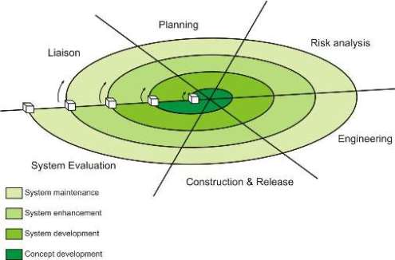

There are between three and six task regions.

* **Customer communication:** tasks required to establish effective communication between developer and customer.
* **Planning:** tasks required to define resources, timelines, and other project related information.
* **Risk analysis:** tasks required to assess both technical and management risks.
* **Engineering:** tasks required to build one or more representations of the application.
* **Construction and release:** tasks required to construct, test, install, and provide user support (e.g., documentation and training).
* **Customer validation:** tasks required to obtain customer feedback based on evaluation of the software representations created during the engineering stage and implemented during the installation stage.

**JUSTIFICATION**

* The spiral model is a realistic approach to the development of large scale systems and software. Because software evolves as the process progresses, the developer and customer better understand and react to risks at each evolutionary level.
* The spiral model uses prototyping as a risk reduction mechanism but, more important, enables the developer to apply the prototyping approach at any stage in the evolution of the product.
* It maintains the systematic stepwise approach suggested by the classic lifecycle but incorporates it into an iterative framework that more realistically reflects the real world.

The spiral model demands a direct consideration of technical risks at all stages of the project and, if properly applied, should reduce risks before they become problematic

PROJECT SCHEDULE

**GANTT CHART**

A Gantt chart is a horizontal bar chart used in project management as a tool for graphically representing the schedule of a set of specific activities or tasks. The horizontal bars indicate the length of time allocated to each activity, so the x-axis of a Gantt chart is subdivided into equal units of time, e.g., days, weeks, months. The y-axis of a Gantt chart, on the other hand, simply lists all the activities or tasks being monitored by the Gantt chart. A simple look at a Gantt chart should enable its user to determine which tasks take the longest time to complete, which tasks are overlapping with each other, etc.

A Gantt chart indicates the following:

1) Durations and timelines of the listed activities;

2) The target and actual completion dates of the activities;

3) The cost of each activity;

4) The person or group of persons responsible for each activity;

5) Milestones in the progress of the project.

**SYMBOLS USED**

Since a Gantt chart is a graphical tool, it employs symbols to represent variety of information about a project. These symbols include:

1) The task bar, which is the horizontal bar used to indicate the duration of each activity in the Gantt chart;

2) The milestone marker, which denotes a major turning point in the project such as the release of an approved budget or the launching of a new product;

3) The link line, which shows the relationship between two tasks, such as the fact that one activity can only begin after another one is complete

SYSTEM DESIGN

**9.1 USECASE DIAGRAM**

A use case diagram at its simplest a representation of user’s interaction with the system &depictingthe specification of use case . A use case diagram can portray the different type of users of a system and the various ways that interact with the system. This type of diagram is typically used in conjunction with the textual use case and will often be accompanied by other type of diagram as well.

Use case diagram depicts.

* **USE CASES:**

A use case describer a sequence of action that providing something of measurable value to an action actor and is drawn as horizontal ellipse.

Notation:-

* **ACTOR:**

An actor is person organization external system plays a role in more interaction with your system. Actor is drawn as stick figures.

Notation:-

* **ASSOCIATION:**

Association between actors and use cases are indicated in use core diagram by solid lines association exists whenever an actor is involved with interaction described by a use case.

Notation:-

* **SYSTEM BOUNDARY BOXES (OPTIONAL):**

We can draw a rectangle around the use cases, called the system boundary box, to indicate the scope of our system, anything within the box represents functionality that is in scope and anything outside the box is not.

Notation:-

* **PACKAGE (OPTIONAL):**

Packages are UML constructs that enable us to organize model elements (such are use cases) into groups.

* **INCLUDE:**

An include relationship is a relationship between two use cases.

Notation :- **<< INCLUDE>>**

* **EXTEND:**

This relationship specifies that the behavior of a use case may be extended by the behavior of another use case

Notation :- **<<EXTEND>>**

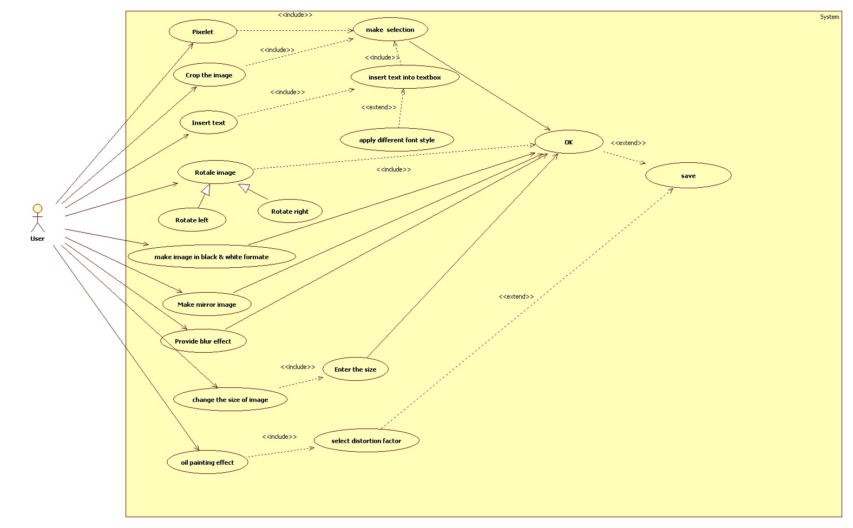

**9.2 ACTIVITY DIAGRAM**

An activity diagram illustrate the dynamic nature by a modeling the flow of control from activity to activity. An activity represent the operation on same class on the system that result in a change in a state of a system. Typically activity diagram are used to model work flow or business process and internal operation. Because an activity diagram is special kind of state chart diagram , is uses some of the same modeling convention.

**BASIC ACTIVITY DIAGRAM SYMBOLS & NOTATION:-**

* **ACTION STATES** : Action state represent non-interptite action of objects we can draw an action state in smart draw using the rectangular with rounded corner.

ACTIVITY

* **ACTION FLOW :-** Action flow arrows illustration the relationship among action states.

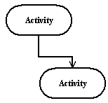

* **INITIAL STATE :-**A filled circle followed by an arrow represents the initial action state.

* **FINAL STATE :-** An arrow pointing to a filled circle nested inside another circle represent the final action sate.

* **BRANCHING :-**A diagonal represent a decision with alternate path . The outgoing alternate should be labeled with a condition or good expression .You can also label one of path “else”.

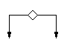

* **SYNCHRONIZTION :-** A synchronization bar helps illustrate parallel transition. Synchronization is also called working and joining

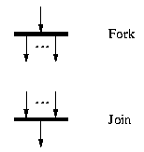

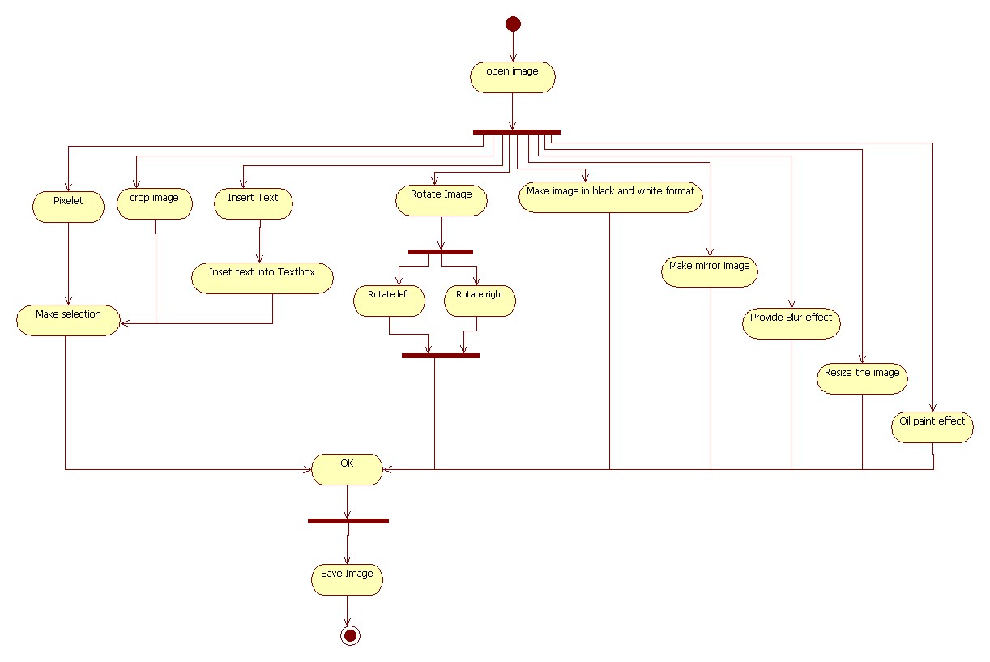

**( ACTIVITY DIAGRAM )**

**9.3 SEQUENCE DIAGRAM**

The sequence diagram models the collaboration of objects based on a time sequence. It shows how the objects interact with other in particular scenario of use case with the advance visual modeling capability we can ere ate complex sequence diagram.

**FOR RESIZE OPERATION:-**

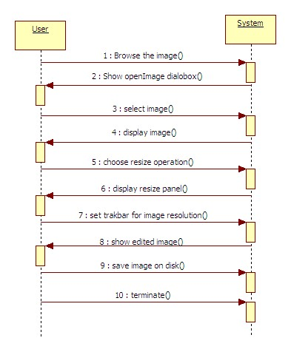

**FOR BLACK AND WHITE EFFECT:-**

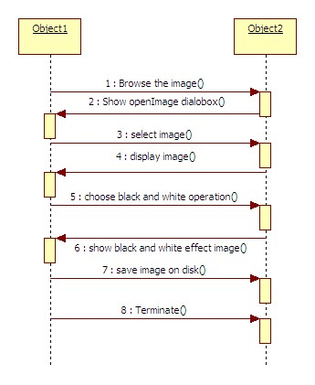

**FOR ROTATE OPERATION:-**

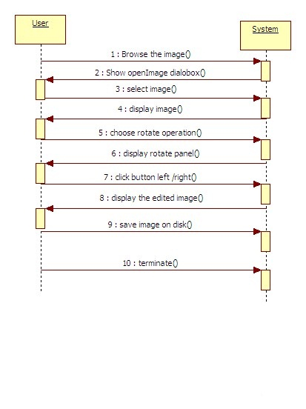

**FOR BLUR OPERATION:-**

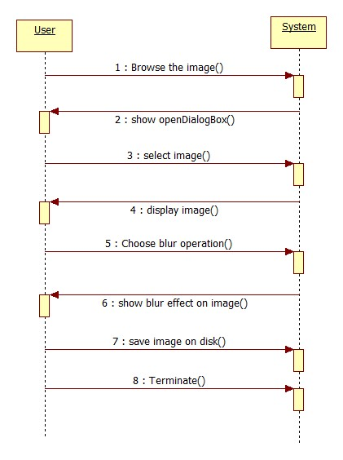

**FOR PIXELET OPERATION:-**

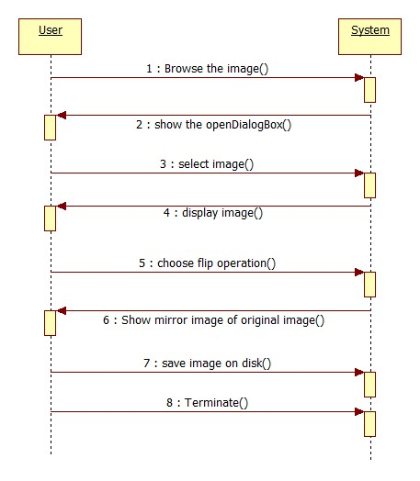

**TESTING**

**10.1 TESTING**:-

Software testing has a dual function. It is used to establish the presence of defects in program and it is used to help judge whether or not the program is usable in practice. The software testing is used for validation and verification, which ensures that software, conforms to its specification and meets the need of the customer. Software is a critical element of software quality assurance and represents the ultimate review of specification, designs and code generation. Once the source code has been generated, software must be tested to uncover as many errors as possible before delivery to the customer

**10.2 Testing objectives**

1. Testing is a process of executing a program with the intent of finding an error.

2. A good test case is the one that has high portability of finding an as-yet undiscovered error.

3. A successful test is one that uncovers an as-yet discovered error.

The main objective here will be to design test cases to uncover different classes of errors and to do so with minimum amount of time and efforts. If testing is conducted successfully it will uncover errors in the software. Another advantage is that it demonstrates that software functions appear to be working according to the specifications and performance requirement have been met.

But Testing cannot show the absence of defects it can show only that software errors are present.

**10.3 STRATEGIES USED FOR SOFTWARE TESTING**

**UNIT TESTING**

Unit testing focuses on verification effort on the smallest unit of software design the software component or module. In this type of testing, the individual modules are tested and verify whether the accurate output is available or not.

**INTEGRATION TESTING**

When the unit testing is over, all the modules are integrated and tested as a whole. It might be possible that all modules may work individually, but they may not work when we put them together. Data can be lost across the interface, one module can have adverse affect on other or sub functions of another, when combined may not produce desired major functions, individually acceptable imprecision may be magnified to unacceptable level; global data structure can present problem. So any system has to be tested this way so that the final output is the desired one.

**VALIDATION TESTING**

After the integration testing software is completely assembled as a package, interfacing error have been uncovered and corrected, and then validation testing may begin. Validation can be defined in many ways but a simple definition is what a validation succeeds when software functions in a manner that can be reasonably accepted by the company.

**SYSTEM TESTING**

System testing is actually a series of different test whose primary purpose is fully exercising the computer based system. Although each test has a different purpose, all work to verify that system elements have been properly integrated and perform allocated functions.Any software is only one element of a larger computer based system. Ultimately software is incorporated with other system elements like hardware, people, information and a series of system integration and validation tests are conducted

SCREEN SHOTS

**FLIP :-**

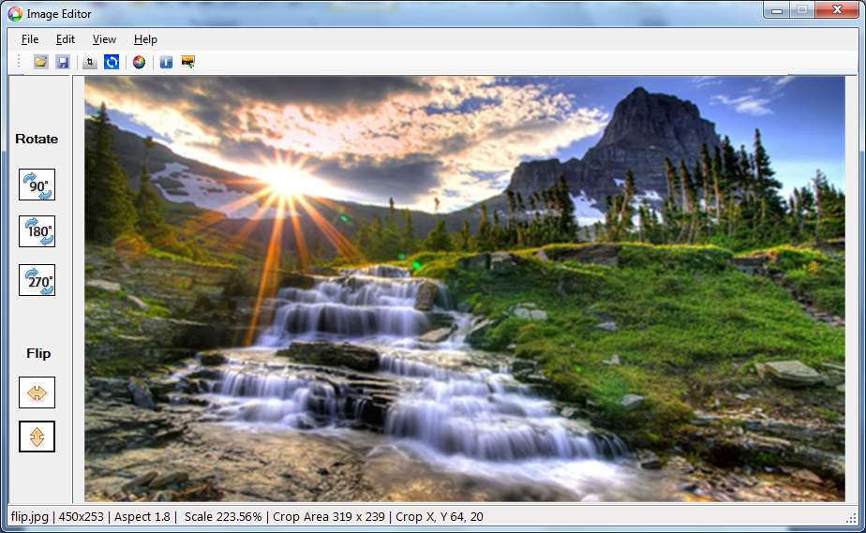

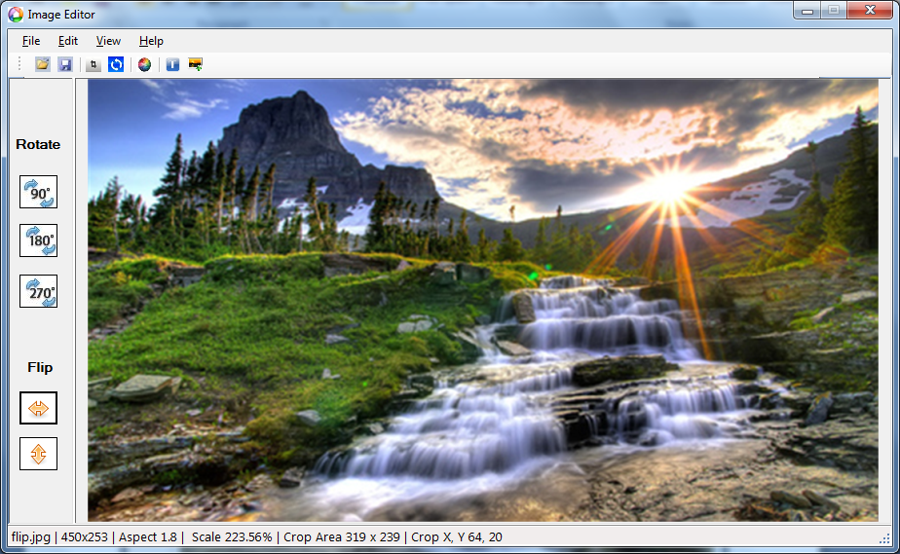

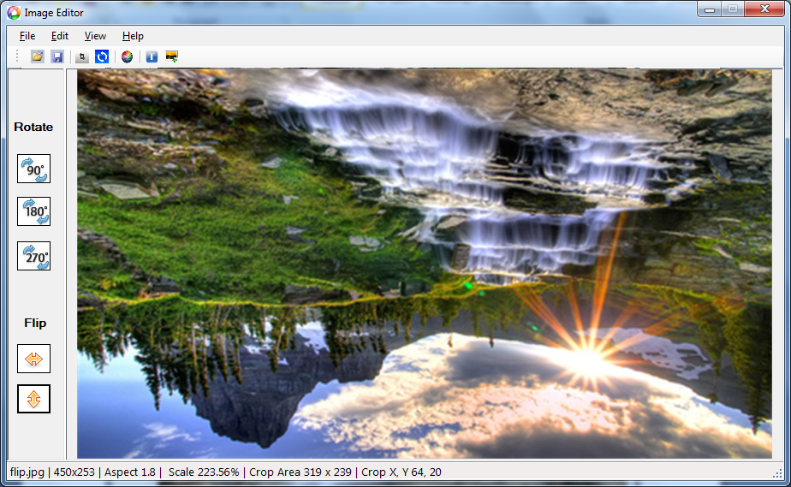

**ORIGINAL IMAGE:-**

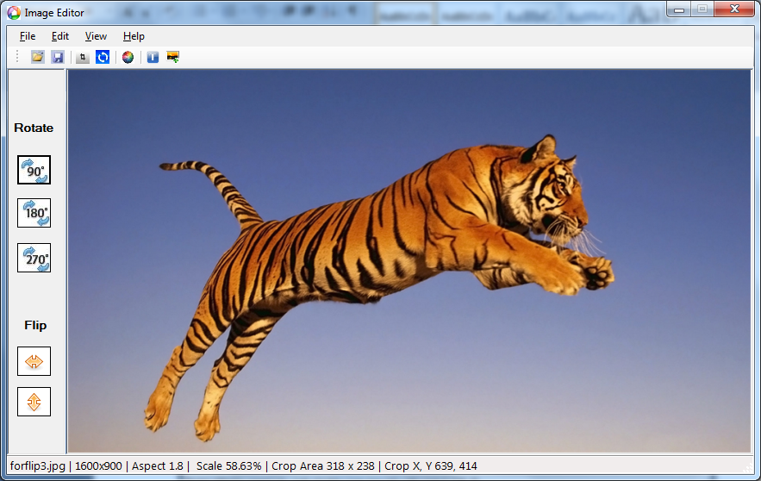

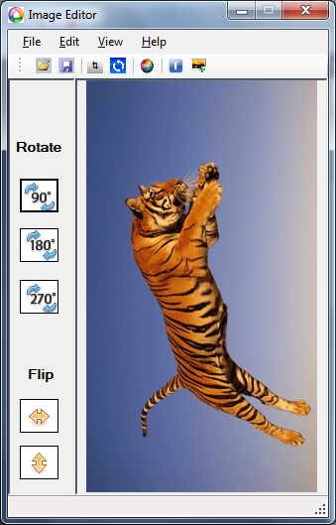 **ROTATE BY 900  ROTATE BY 1800**

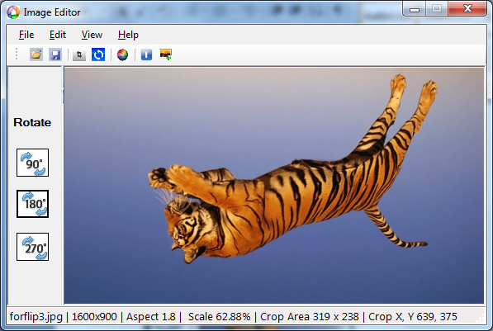

ROTATE BY 2700

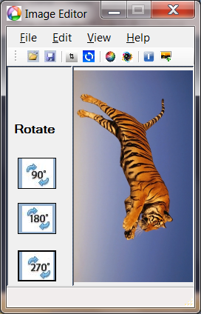

**COLOR EFFECT**:-

* INVERT:-

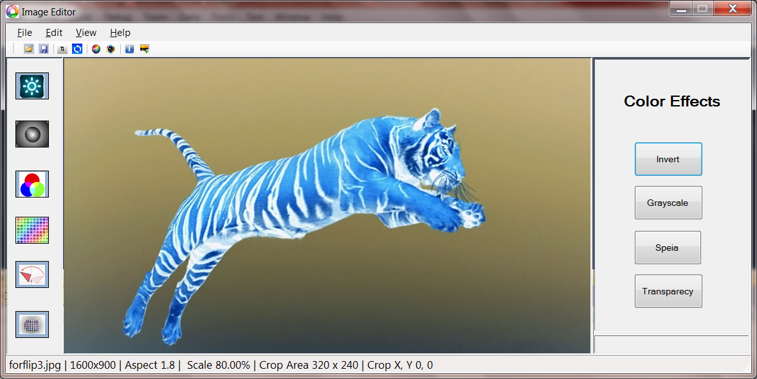

* SEPIA:-

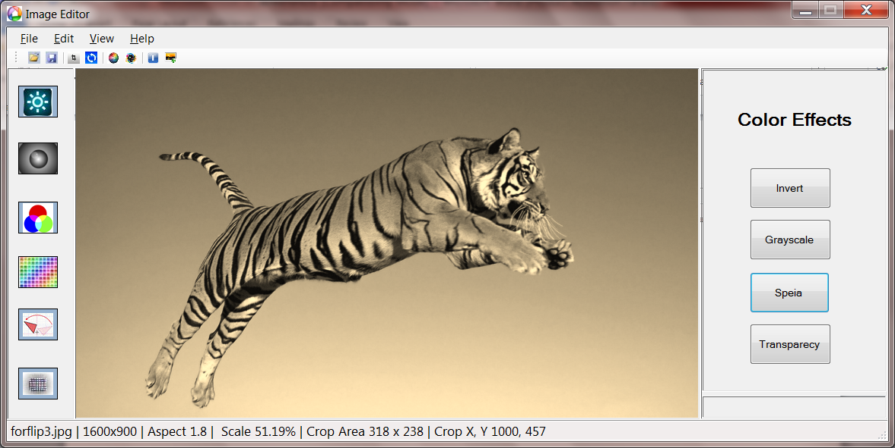

* TRANSPARENCY:-

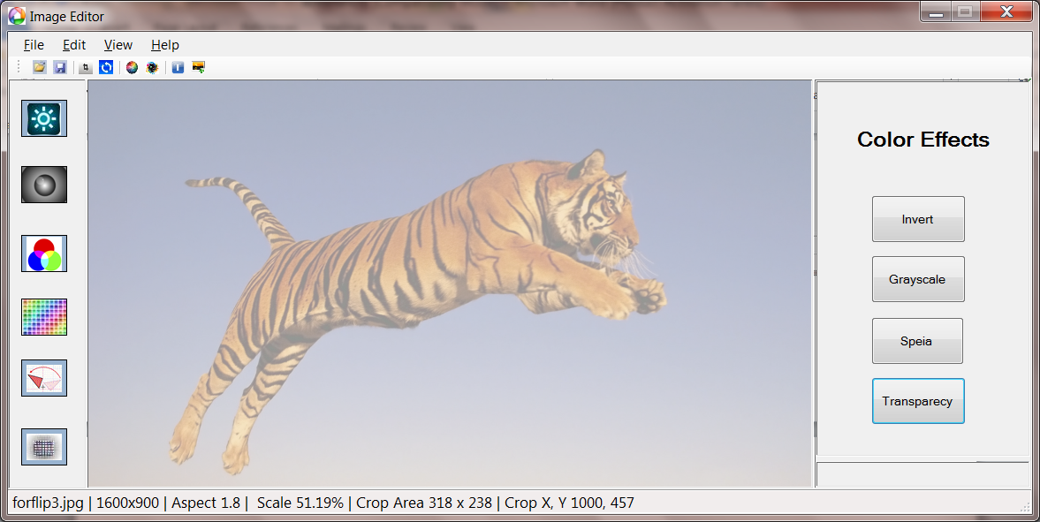

* GRAYSCALE:-

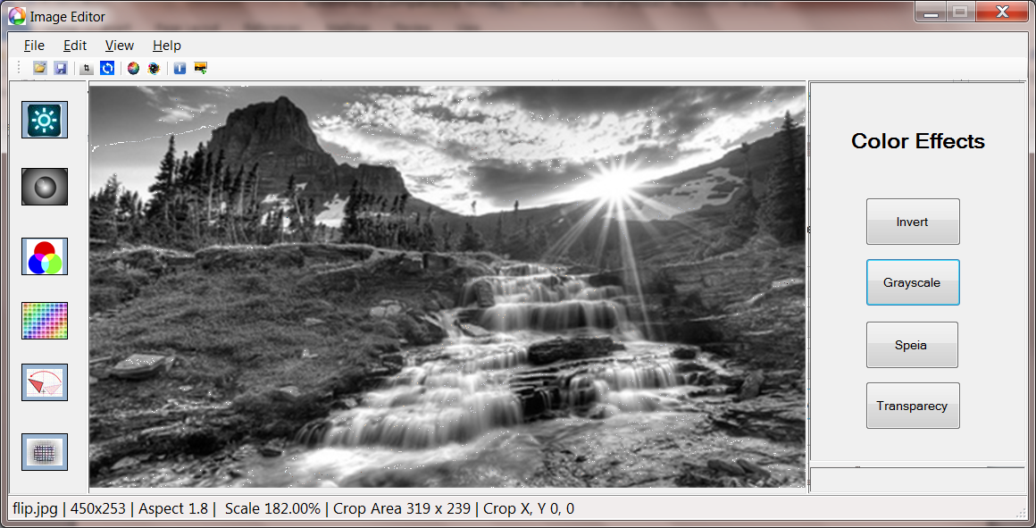

**BLUR EFFECT**:-

**ORIGINAL IMAGE BLURRED IMAGE**

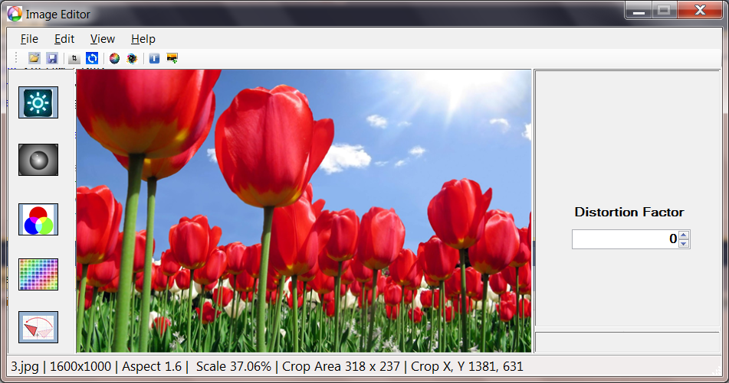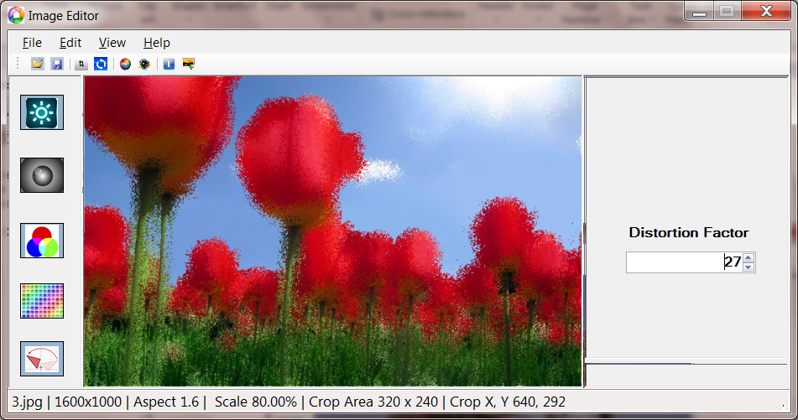

**INSERT TEXT:-**

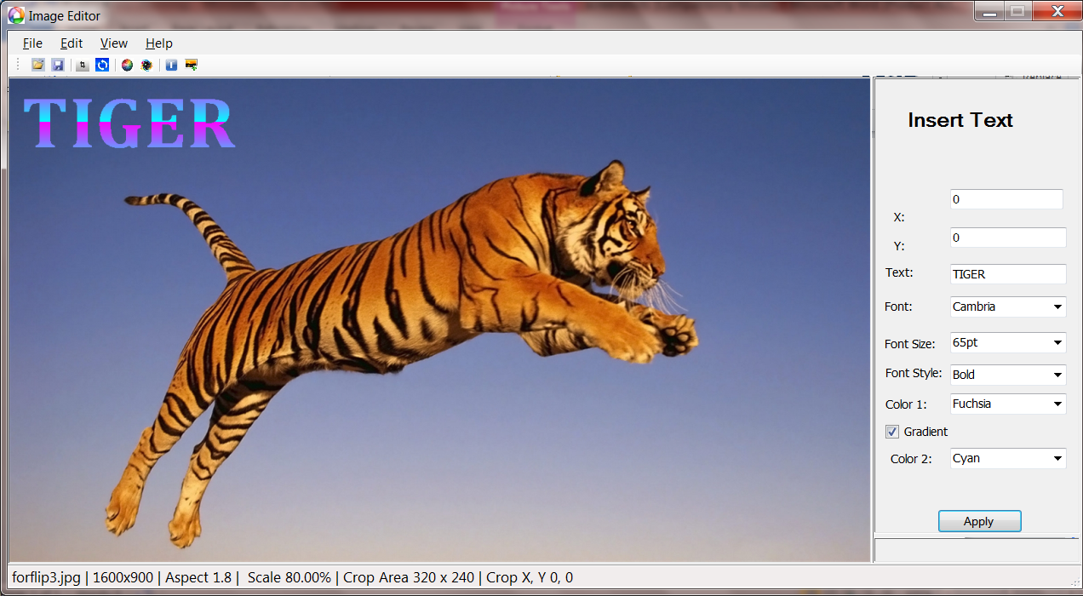

**TRANSFORM ROTATION**

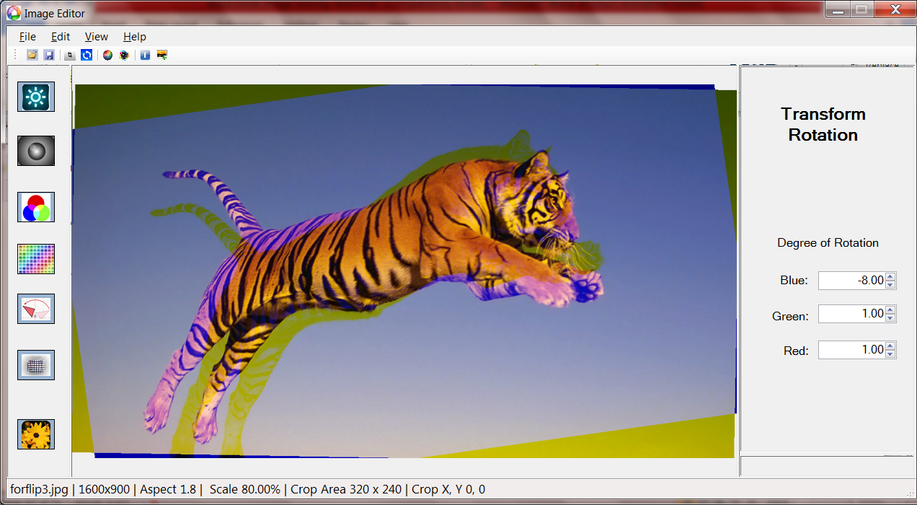

**BRIGHTNESS**

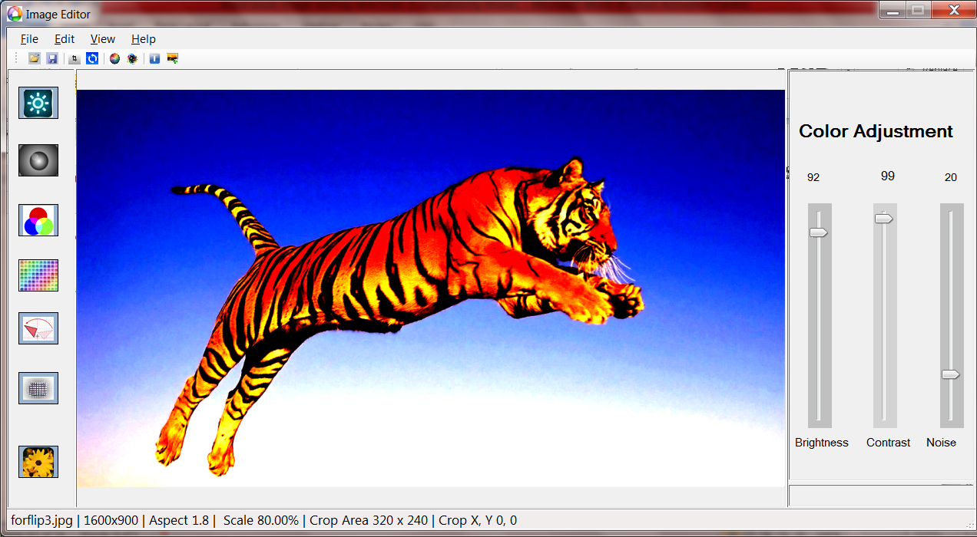

**COLOR FILTER:-**

**ORIGINAL IMAGE:-**

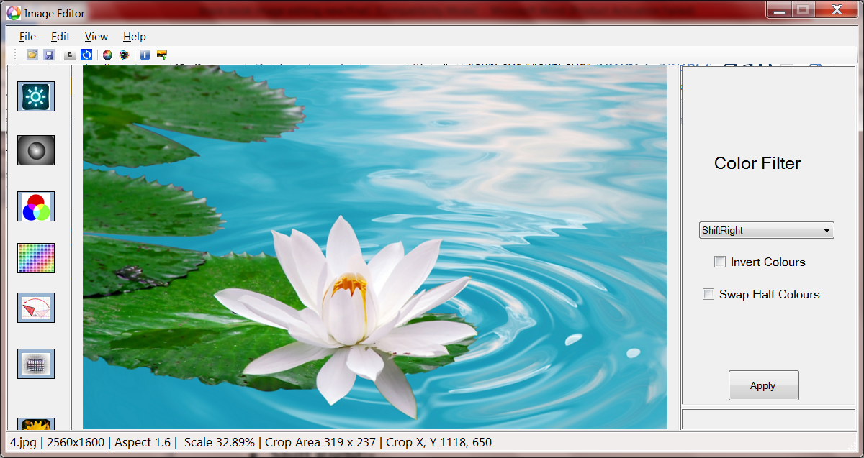

* **INVERT COLOR:-**

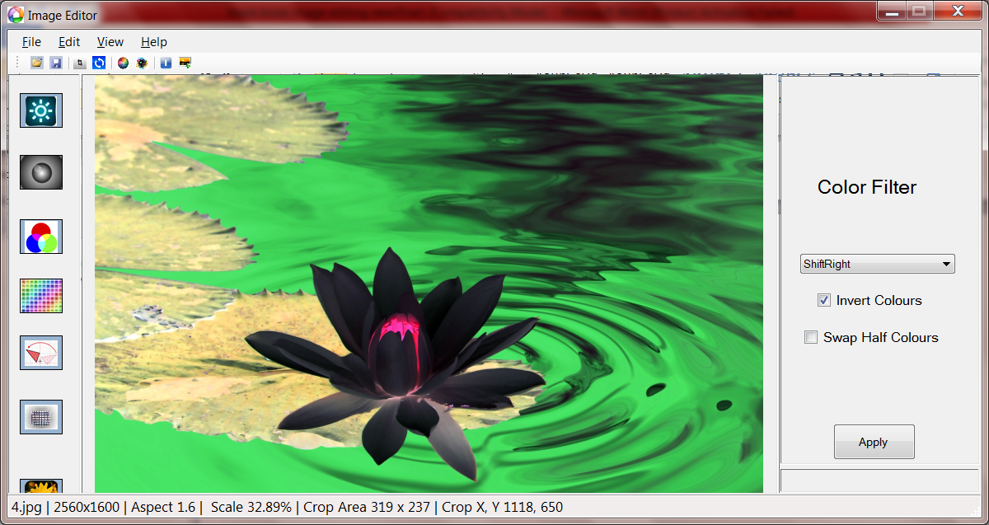

* **SWAP HALF COLOR:-**

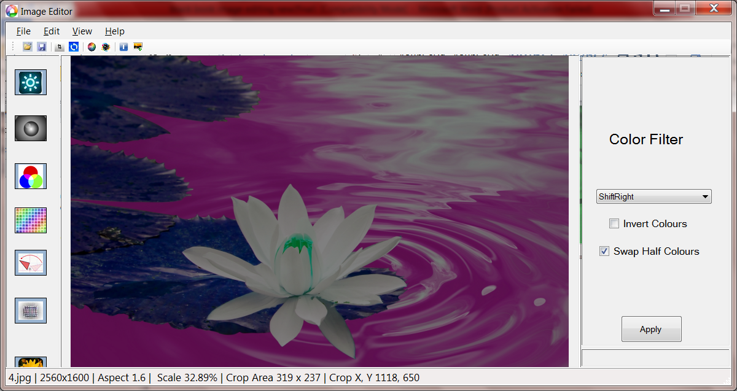

* **SHIFT LEFT:-**

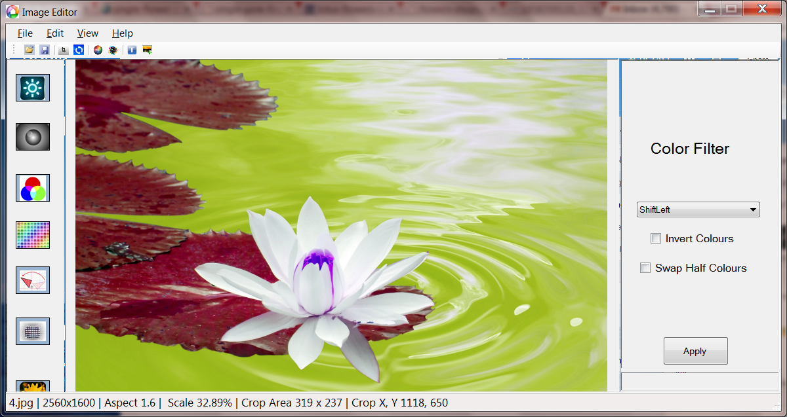

* **SHIFT RIGHT:-**

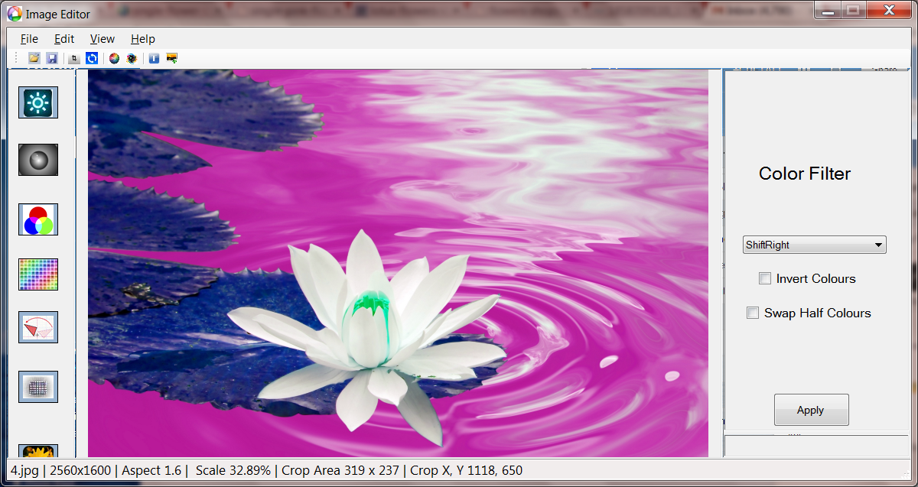

* **SWAP BLUE AND GREEN:-**

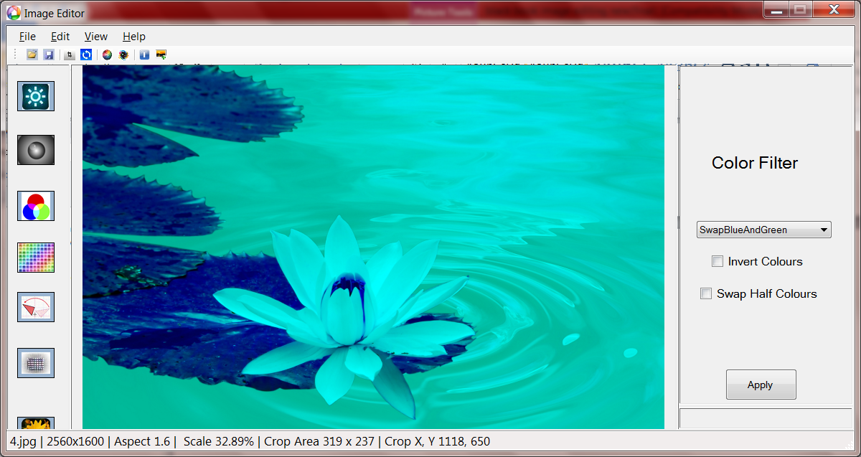

* **SWAP BLUE AND RED:-**

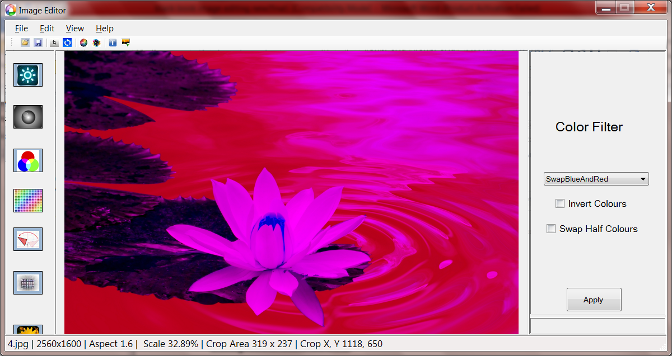

* **SWAP RED AND GREEN:-**

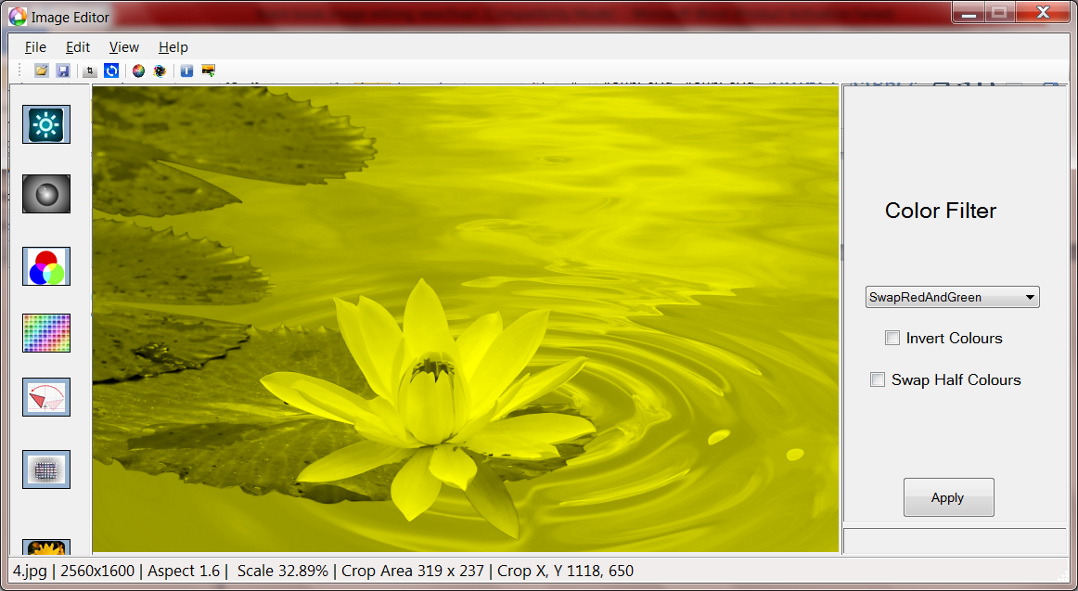

**DEPLOYMENT**

**DEPLOYMENT**

**12.1 DEPLOYMENT**

Software deployment is all of the activities that make a software system available for use. The general deployment process consists of several interrelated activities with possible transitions between them. These activities can occur at the producer site or at the customer site or both. Therefore, “deployment” should be interpreted as a general process that has to be customized according to the specific requirements or characteristics.

**12.2 SOFTWARE DEPLOYMENT**

**Software’s to be installed**

* Microsoft visual studio 2010

**SYSTEM MAINTENANCE AND EVOLUTION**

**13.1 SYSTEM MAINTENANCE**

The maintenance of software is the period in which the software product useful work. Maintenance activities involve making enhancement activities to the adapting product to new environment and corrective problems. Software enhancement may involve providing new functional capabilities, improving user displays and mode of interaction.

Adaptation of software to a new environment may involve moving the software to a different machine. Problem correction involves modification and re-validation of software to correct errors. The four types of maintenance activities are describe below

* 1. **CORRECTIVE MAINTENANCE**

Corrective maintenance is the most commonly used maintenance approach, but it is easy to see its limitations. When equipment fails, it often leads to downtime in production, and sometime it causes spreading of damage to other parts. In most cases this is costly business. Also, if the equipment needs to be replaced, the cost of replacing it alone can be substantial. Reliability of system maintained by this type of maintenance is not known and cannot be measured. Therefore, corrective maintenance is carried out on all items where the consequences of failure or wearing out are not significant and the cost of this maintenance is not greater than preventive maintenance.

**13.3ADAPTIVE MAINTENANCE**

Adaptive maintenance is an activity that modifies software to properly interface with the changing environment.

**13.4 PERFECTIVE MAINTENANCE**

Perfective maintenance is performed to satisfy user requests such as new Capabilities, modification to existing function and general enhancements.

**13.5PREVENTIVE MAINTENANCE**

Preventive maintenance occurs when the software is changed to improve future maintainability or to provide a better basic for future enhancements

.

**13.6 FUTURE ENHANCEMENT**

In future releases of this application, there will be more features available for user in order to edit the image

**CONCLUSION**

**CONCLUSION**

This software is developed successfully and it was given to many users who liked it. They have used the software and they find it is very attractive and useful.

The first guidance was given by the project guider then I planned all the possible things and also make the rough GUI. After it I started the basic operation in the image. Various changes have been made in between the project.

The project inspection is conducted after completion of the project forthe first time. The project was seen by many professors in my department. After inspection they advised more changes and they told me to add another activity in the project. After few days, I completed those things and showed the project to my project guide and my colleagues. They liked my project and find it very interesting. In between the project they get the funny movement in between the image in project.

**BIBLIOGRAPHY**

**BIBLIOGRAPHY:-**

* Code Project

<http://www.codeproject.com>

* C SharpCorner

<http://www.c-sharpcorner.com>

* Stack Overflow

[www.stackoverflow.com](http://www.stackoverflow.com)

* System.Drawing Namespace

<http://msdn.microsoft.com/en-us/library/gg145023(v=vs.110).aspx>

* Google Search

[www.google.co.in](http://www.google.co.in)

* tutorials of programming languages

http://www.tutorialspoint.com/computer_programming_tutorials.htm